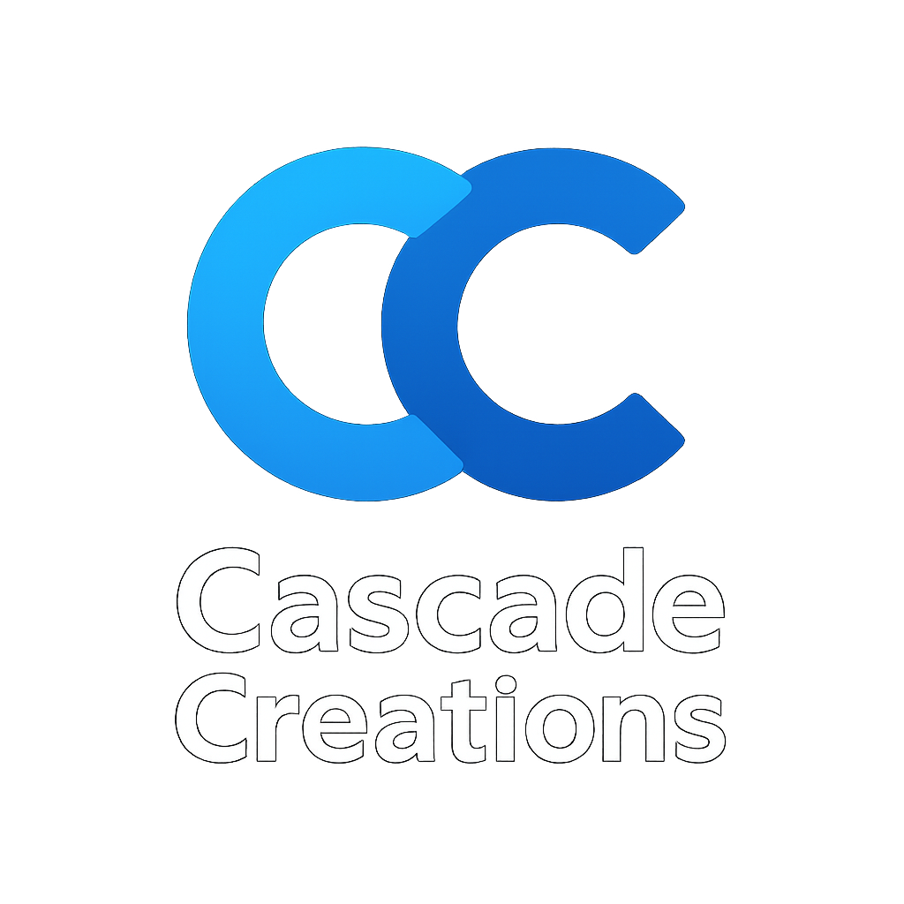

**Cascade Creations Business Plan**

**Executive Summary**

Cascade Creations is a professional web design and development company dedicated to creating sleek, responsive, and user-friendly websites for individuals, startups, and small to medium enterprises (SMEs). With a strong foundation in HTML5, CSS3, JavaScript, React, Bootstrap, and design tools like Figma, Cascade Creations delivers modern, affordable, and scalable solutions.  
Our mission is to empower businesses and professionals with digital platforms that enhance visibility, credibility, and growth.

**Business Objectives**

Deliver affordable, high-quality websites tailored to client needs.

Establish long-term client relationships through consistent support and maintenance.

Expand services to include e-commerce solutions, app integrations, and digital marketing add-ons.

Position Cascade Creations as a recognized brand in the SME digital solutions space within South Africa and beyond.

**Services Offered**

Website Design (New Builds) – Professional websites built from scratch.

Website Refurbishment & Redesign – Modernizing outdated sites with fresh designs.

Front-End Development – Using HTML5, CSS3, JavaScript, React, and Bootstrap for clean, scalable, and responsive builds.

Website Optimization – Performance tuning, SEO, and mobile-first layouts.

Custom Solutions – Tailored features like contact forms, booking systems, and product showcases.

Future Expansion – Secure e-commerce solutions and lightweight app integration.

**Target Market**

Cascade Creations focuses on individuals and businesses that require affordable, yet professional digital presence:

Small businesses & entrepreneurs (retail shops, restaurants, service providers).

Creative professionals (photographers, artists, consultants).

Skilled service providers (welding, carpentry, event services).

Startups & NGOs seeking modern branding through online visibility.

**Marketing Strategy**

Portfolio-driven Website – Displaying completed projects with case studies.

Social Media Marketing – Active presence on Instagram, LinkedIn, and Facebook.

Word-of-Mouth & Referrals – Leveraging client satisfaction for organic growth.

SEO Optimization – Ensuring Cascade Creations own website ranks for relevant searches.

Community Networking – Collaborating with small business hubs, co-working spaces, and local entrepreneurs.

**Revenue Model**

Project-Based Fees – One-time payments per completed website/refurbishment.

Value-Added Services – Optional add-ons like SEO, maintenance, and e-commerce integration.

Starter Packages – Affordable bundles for startups (domain, website, basic branding).

Recurring Revenue – Maintenance retainers and upgrade packages.

**Operations Plan**

Tools & Technologies: VSCode, GitHub, Figma, Bootstrap, React, JSON.

Project Management: Trello and Notion for timelines and deliverables.

Client Communication: Email, Zoom, and Google Meet for consultations and updates.

Delivery Timeline: Standard projects completed in 2–4 weeks depending on complexity.

**Financial Plan (Year 1 Example)**

Startup Costs:

Domain & hosting: R1,500

Branding & marketing: R5,000

Tools/software subscriptions: R3,000

Revenue Projections:

Average website build: R6,000 – R15,000 (depending on features).

Target: 3–5 projects/month.

Annual revenue projection: R216,000 – R540,000.

Expenses:

Marketing campaigns, admin, and tool subscriptions (~R60,000 annually).

Break-Even Target:

Within 6–8 months of operations.

“At Cascade Creations, we design and develop sleek, responsive websites tailored to your brand. Whether you're starting from scratch or refreshing your digital presence, CrySites delivers modern solutions that work beautifully across all devices.”

